**STATUS REPORT**

**TEAM 11**

1. ACHIEVEMENTS

* Sprint 2 completed
* Retrospective meeting
* Review meeting
* By adding extra features we have widen the scope as per review
* 67% of project has been completed
* Further updates and information will be mentioned in the review meeting
* Was able to complete the sprint as per schedule due to increase in communication and team dynamics

2.BURNDOWN CHART

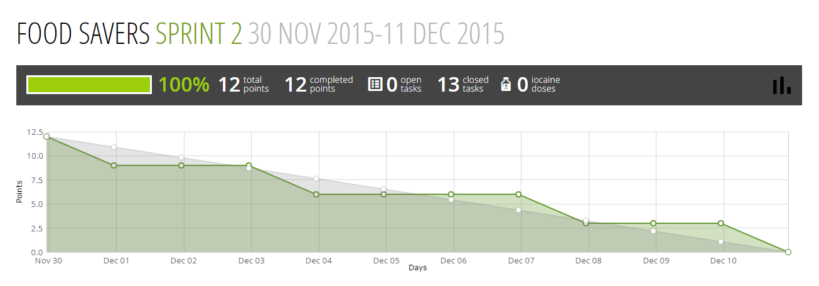

3.ISSUES

* there was slight deviation in the plan
* we have used our buffer time
* reason for deviation was widening the scope
* burn down chart shows the respective deviation in design and development phases